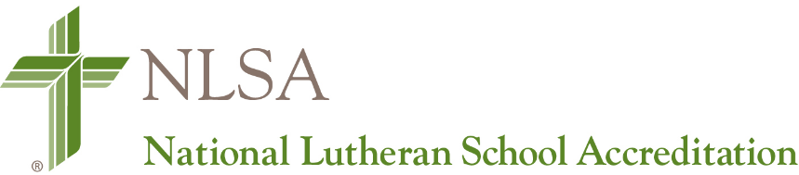
August 15, 2019

Dear Colleagues in Christ,
The annual meeting of the National Lutheran School Accreditation (NLSA)– National Accreditation Commission (NAC). NLSA-NAC was held July 30 – August 1 to affirm LCMS schools and conduct the business of NLSA.
The National Accreditation Commission acted on the following items:
NAC awarded accreditation to 131 schools bringing the total number of accredited schools to 682.
NAC reviewed recommendations submitted from districts. Affirmed changes will be incorporated in the NLSA documents and posted on LuthEd September 1.
NAC affirmed a protocol change for schools seeking dual accreditation with AdvancED. In consultation with Merry Clark and Dr. Eddie Krenson, NLSA is pleased to announce that beginning September 2019, LCMS schools will be able to use NLSA protocol (NLSA EBA in place of AdvancED protocol) as the primary tool for the process. Schools accredited in good standing by NLSA will be required to submit a fee of $1,200 AdvancED and the annual fee to NLSA.
Reciprocity does not extend to Early Learning programs unless the NLSA EC 2018 document is recognized by the state as an approved protocol for its state-tiered programs. Where NLSA is an accepted protocol, AdvancED will extend dual accreditation to Early Childhood Centers using the NLSA EC 2018 protocol.
For schools with an integrated early childhood program who are not interested in accessing a state tiered program, AdvancED will extend dual accreditation for preschool – grade 8 (or grade 12) schools with the completion of NLSA EBA protocol.
We will continue to work with AdvancED to assist schools who have Validation Team Visits in 2019-2020 who have already begun using AdvancED’s protocol. Kristin Freeman will be sending you a list of schools in your district that have indicated that they are pursuing dual accreditation. Please contact your AdvancED schools and inform Kristin regarding the protocol they will be using.
The NLSA budget was presented with historic data regarding personnel expenses (associate director and coordinator salary, benefits and General and Administrative [G & A] expenses) and general operating costs. Personnel and G & A expenses comprise 74.5% and general operating costs reflect 15.3%. The budget reflects a current surplus of $50,000 (from staffing changes and preplanning for online accreditation).
An NLSA Online Accreditation Proposal was presented. Three providers (Armature, Open Water, WizeHive) were considered. Armature had the most capacity to serve NLSA needs with:
- a seamless process from application to accreditation
- all school data and the accreditation in one place
- online hosting and access
- payment process functionality
- simple and intuitive
With the budget review and anticipated costs to move forward with the Online Accreditation Proposal, a fee increase is necessary to move ahead with online accreditation submission. The following models were presented:
- Reduction of a Flat Fee
- Implementation of Per Pupil Fee
- Sliding Scale based on School Enrollment
- Flat Fee Structure
NAC approved the Flat Fee Structure with an increase of $50 each year for 3 years beginning September 2019 in order move forward with the Armature Online Submission process. The increase will be reflected on the NLSA invoice schools receive at the end of August.
- 2019-2020 - $650
- 2020-2021 - $700
- 2021-2011 - $750
NAC elected its new officers for the Executive Committee. Chairman Jane Limback and Secretary Janet Profilet were warmly thanked for their years of service and new members were welcomed.
Chairman – Keith Wilharm, NID NLSA Commissioner
Chairman Elect – Joel Wahlers, CNH NLSA Commissioner
Secretary – Matthew Schleicher, Texas NLSA Commission Vice Chair
Formal letters affirming accreditation will be sent to each school next week. Minutes from the NAC meetings will be posted on LuthEd at the end of August. We thank the Membership Committee and the National Accreditation Commission for their dedicated work on behalf of schools.
In His Service and yours,
Becky Schmidt
Rebecca S. Schmidt, Ed.D.
LCMS Director of School Ministry
800.248.1930 Ext. 1716
Rebecca.Schmidt@lcms.org

