PO Box 228 315 Martin Luther Drive
Martin
Luther High School

Northrop, MN 56075 Phone: 507-436-5249
www.martinlutherhs.com

Honoring Christ...Welcoming All

Strategic Plan
2019-2022

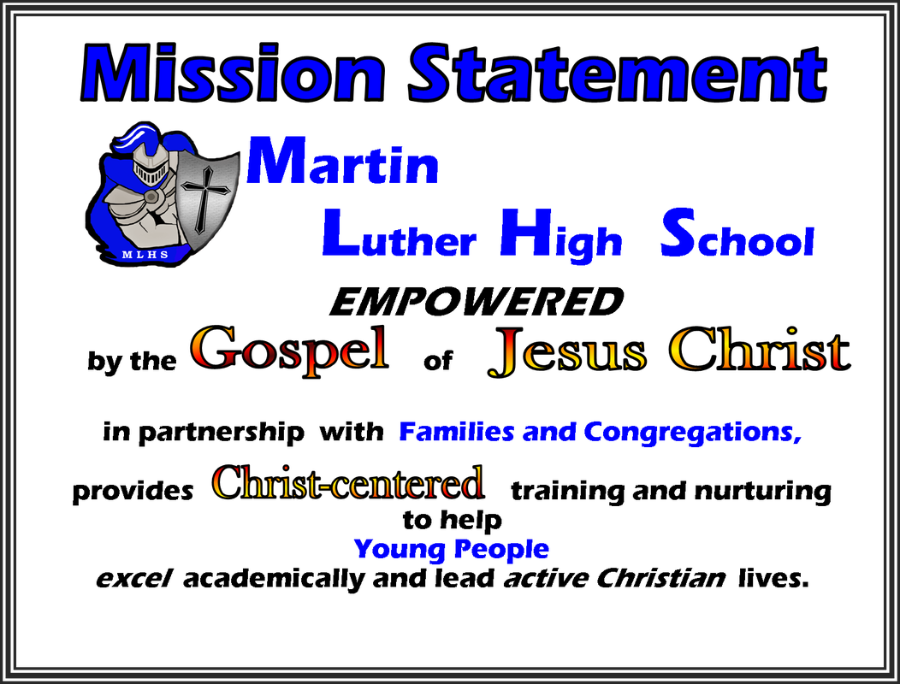

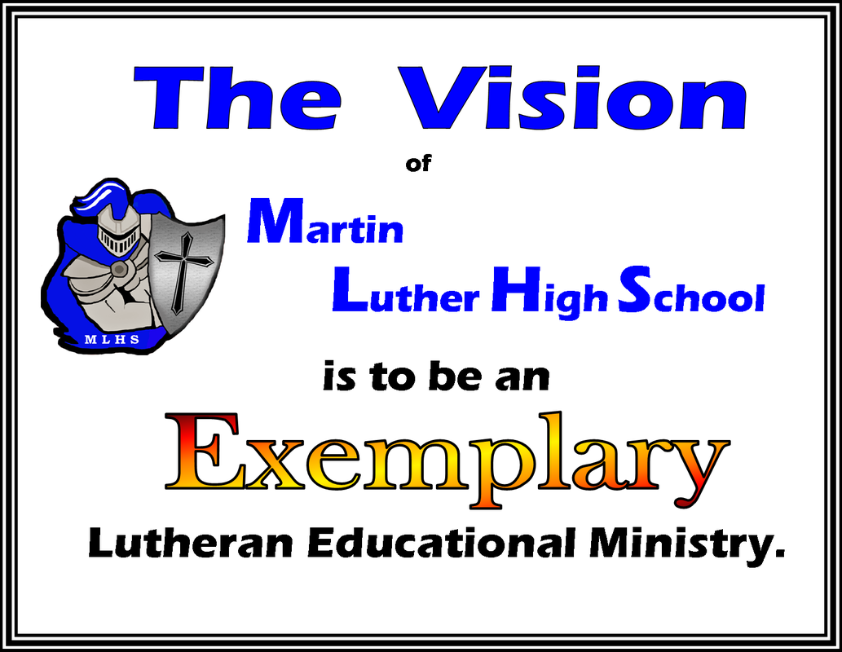

The following are the goals MLHS will pursue in compliance with the Great Commission via the MLHS Mission and Vision statements over the next three years. These goals are to be immediate, measurable, and strategic beyond our normal pursuits of excellence.

A. Financial
- Have our role (purpose) within our churches and community re-evaluated by our delegates and our association.
- Restructure our financial plan.
- Research 3rd Party Income.
- Coffee
- Rummage Sale House
- Day Care
- products from the greenhouse

B. Academic and Athletic
- Explore a Robotics Component to be added to our technology class.
- Explore Consumer (Stewardship) Math as a graduation requirement.
- Promote “unity” of our area Lutheran Schools including shared teaching resources: science, art, spanish, etc.
- Develop our “CER” program.
- Develop a eSports program.
- Research the addition of a Speech & Debate Team.
- Finish Greenhouse as a year-round usable classroom.

C. Communications
- Generate an online enrollment process as well as streamline our existing process.
- Reach a larger community with our message. (undefined parameters & undetermined budget impact)
- Update policy handbooks: student/parent, staff, and curriculum.
- Annual surveys to students and parents.

D. Board Level
- Establish President’s Advisory Committee.
- Develop Administrator Evaluation Process.
- Re-Write our Mission and Vision Statements with our target audience at the center.

